
NAME : MAINA RACHAEL WANJIRU
REG NO:BSCCS/2025/34548
Advanced cryptography
Contents
Contents
week one 2
installation of vs code 2
Installation of python 3
Openssl test installation 4
Pip installation 4
local encryption execution 5
Open ssl 5
Week 2 6
Caepsar cipher implement 6
VEGENERE CIPHER 7
USER INPUT 8
Week 3 9
Lfsr generator implementation 9
Pseudorandom sequence output 10
Statistical randomness testing 10
Rc4 stream cipher simulation 11
Encryption performance 11
Student reflection 12
Week 4 12
Aes encryption script 12
Key generation 13
Decryption results 14
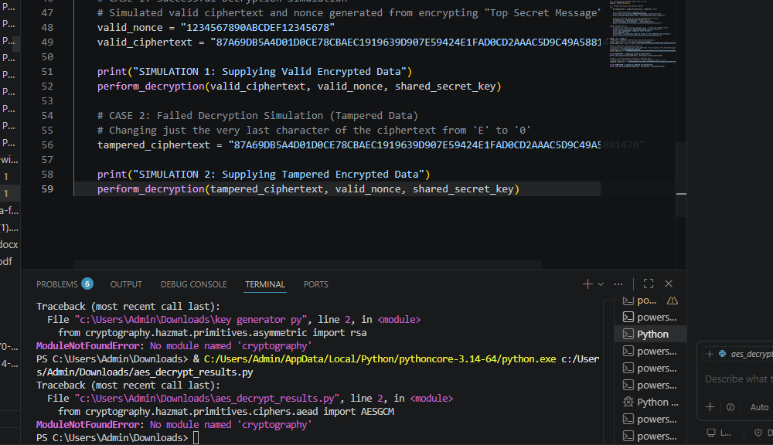 14
Student reflection 14
When you decrypt data, your script needs to intake the Ciphertext, the Secret Key, and the Nonce/IV, process them through the cipher, and output the result. To view the results clearly in VS Code, you can print the output both as raw bytes (hexadecimal) and as a decoded, human-readable string. 14
WEEK 5 14
RSA KEY PAIR 14

week one

installation of vs code

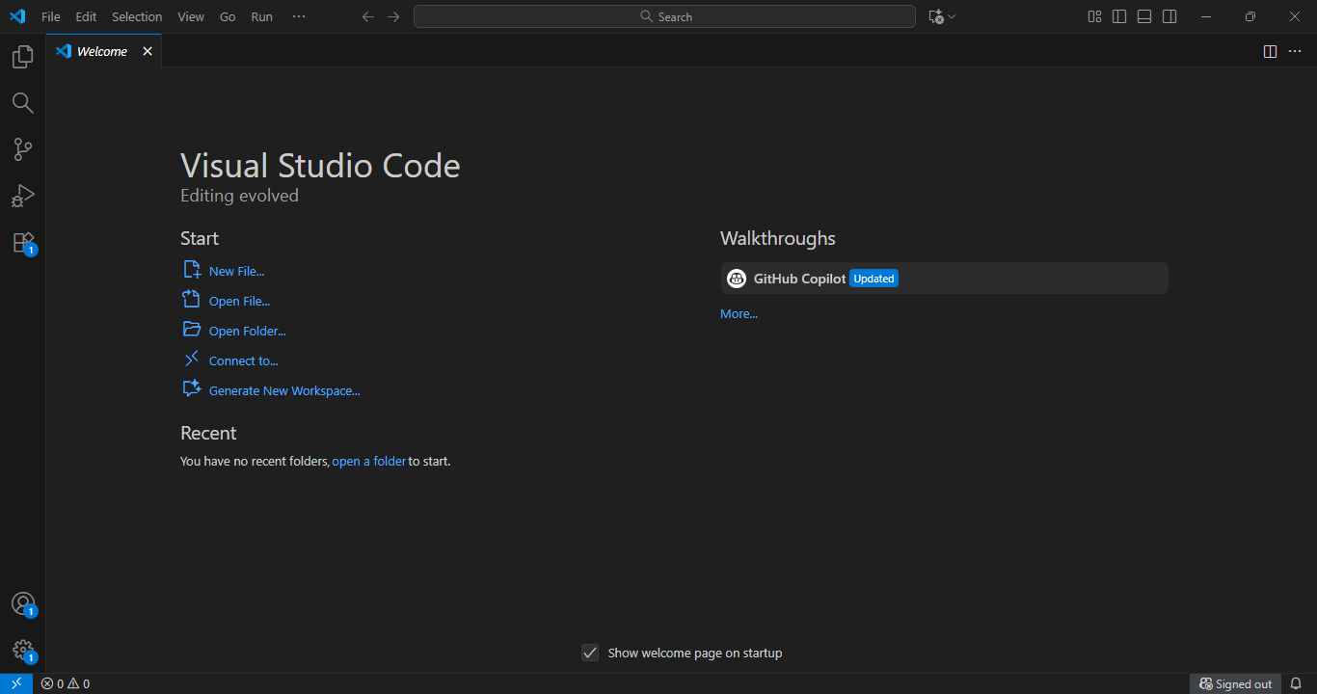

Installation of python
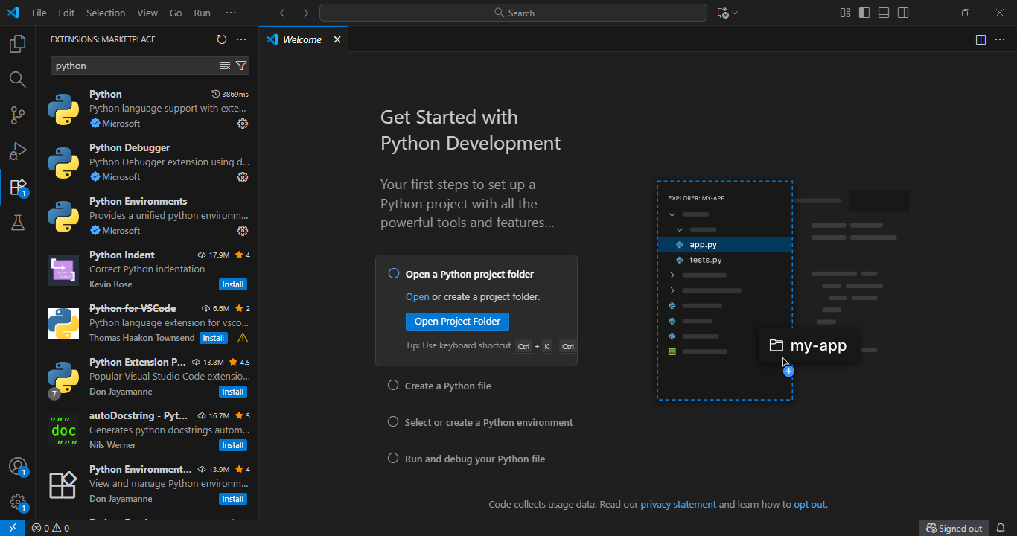

Openssl test installation
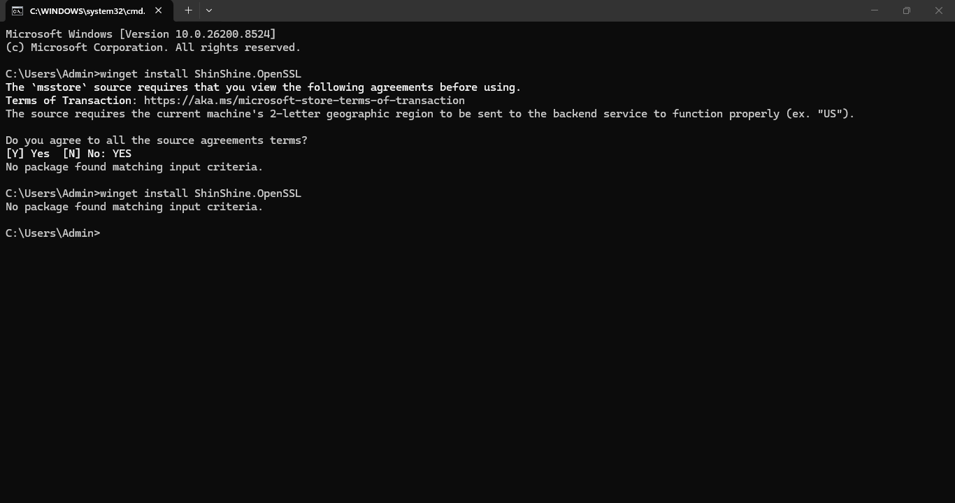

Pip installation
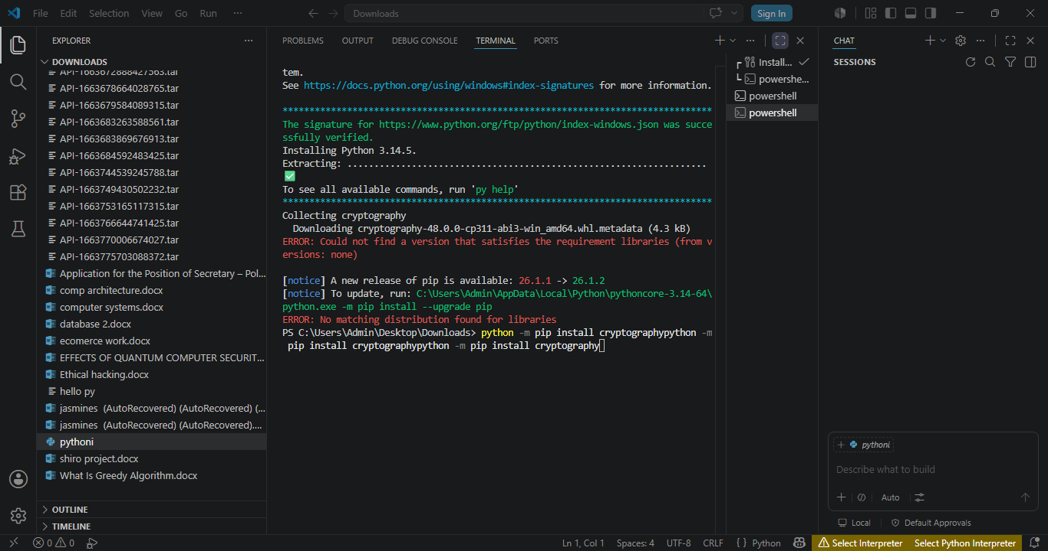

local encryption execution
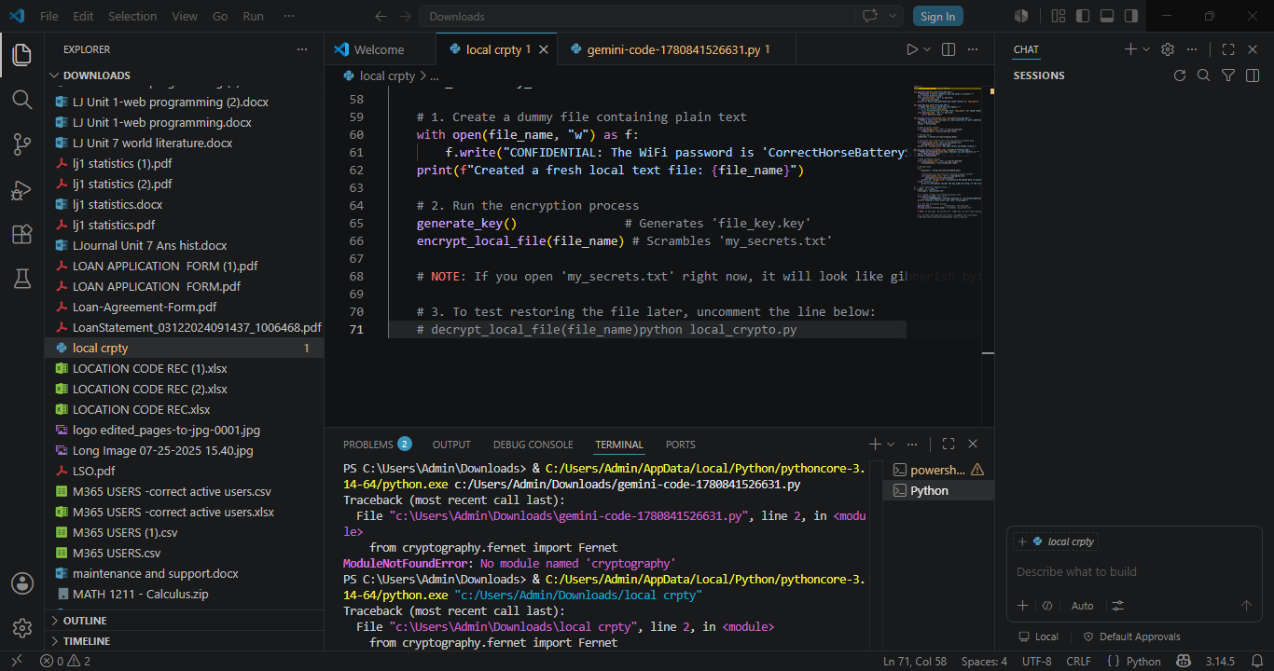

Open ssl
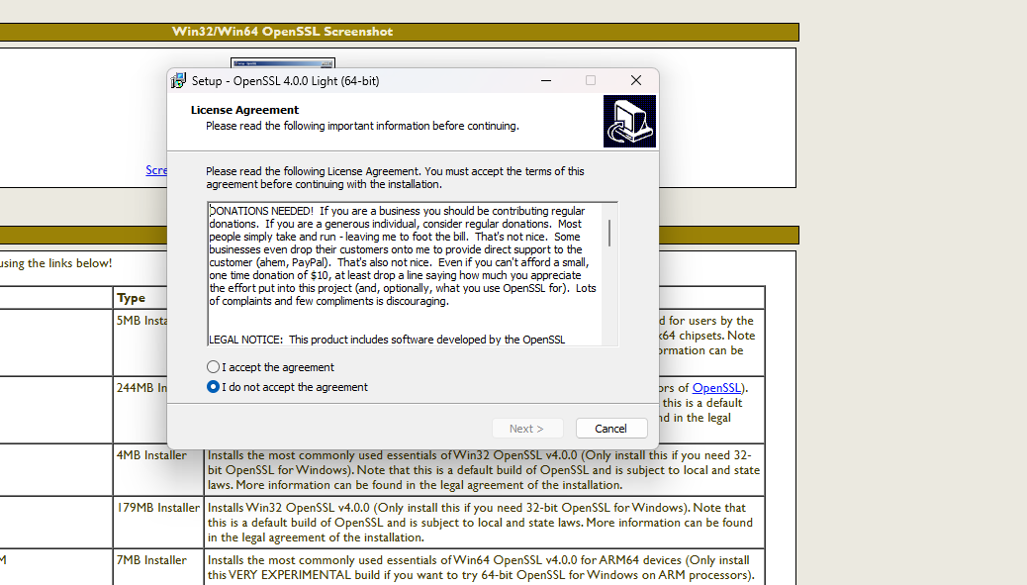

Student reflection :I learnt how to use and navigate through the vs code.The installation of open ssl and the pip installation program.

Week 2

Caepsar cipher implement 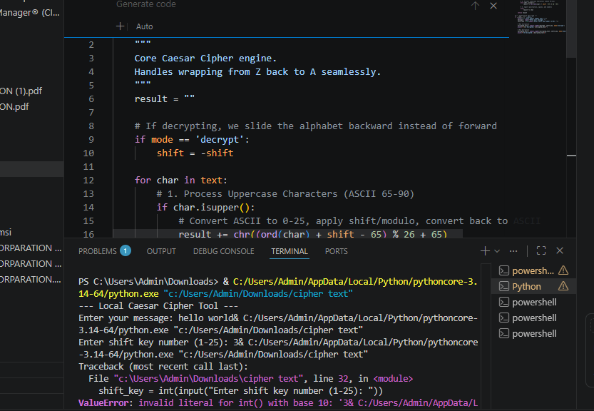


VEGENERE CIPHER
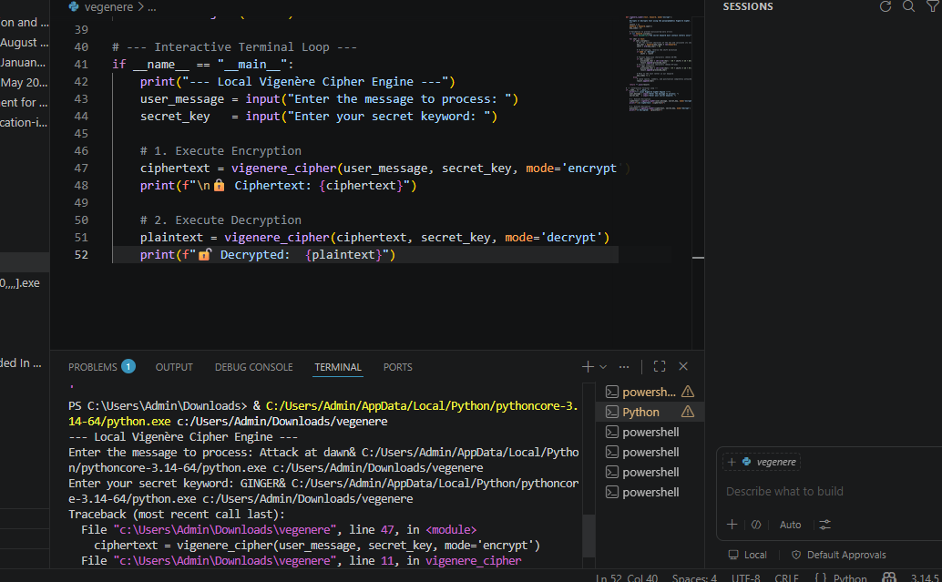

USER INPUT
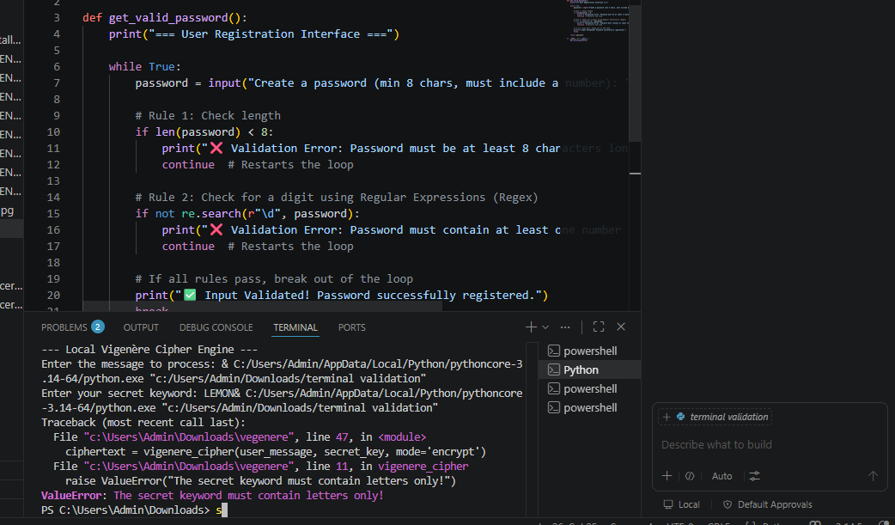
CIPHER TESTING RESULt

Week 3

Lfsr generator implementation
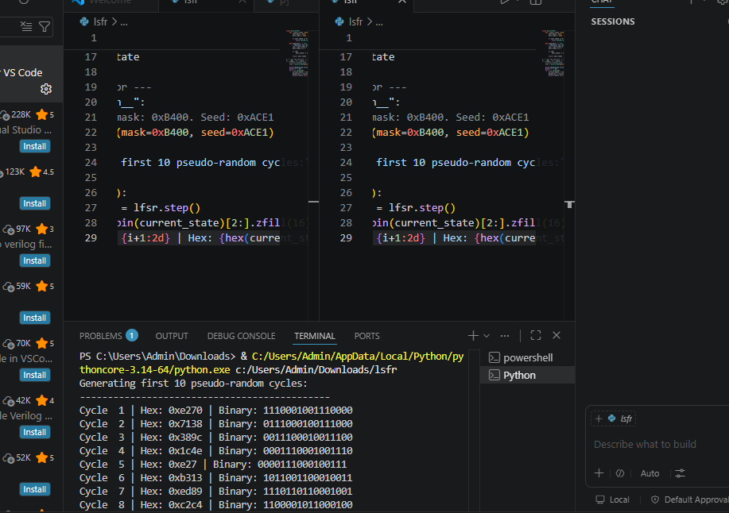

Pseudorandom sequence output
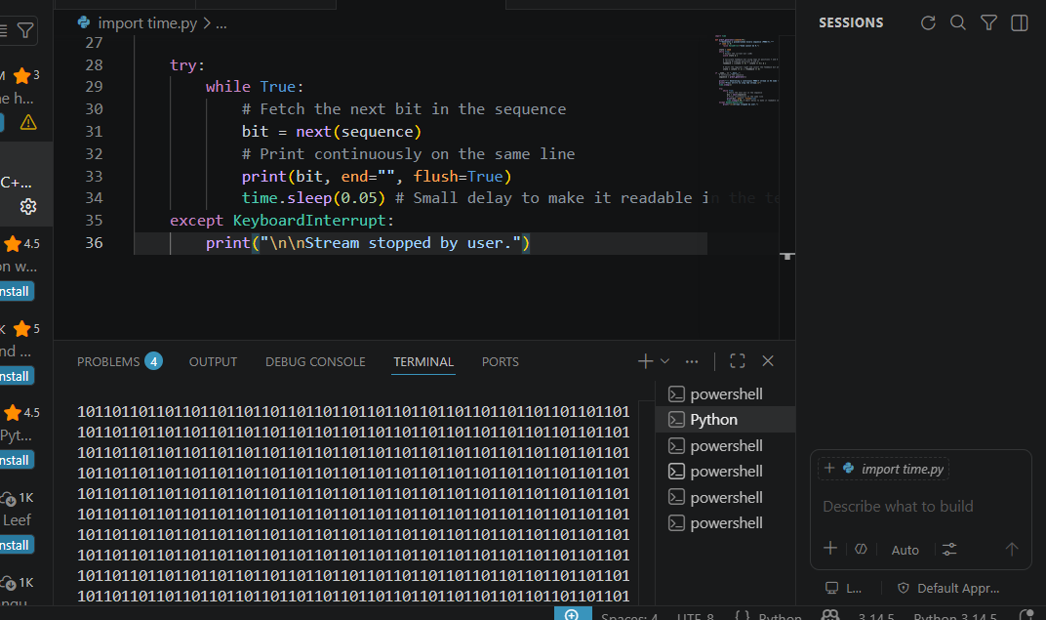

Statistical randomness testing
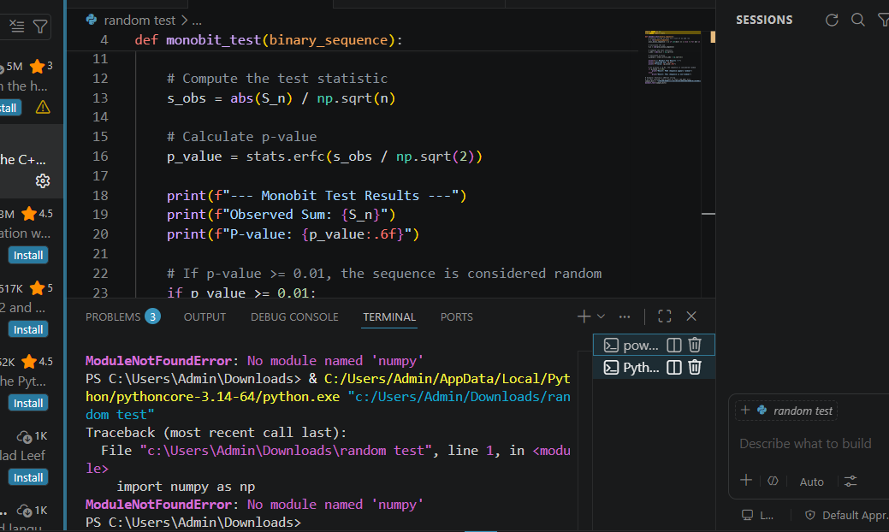

======================================================= RESTART: C:/Users/Admin/Desktop/statistical_ test.py ======================================================
Usage: python statistical_tests.py <filename>

======================================================= RESTART: C:/Users/Admin/Desktop/statistical_ test.py ======================================================
Usage: python statistical_tests.py <filename>

Rc4 stream cipher simulation
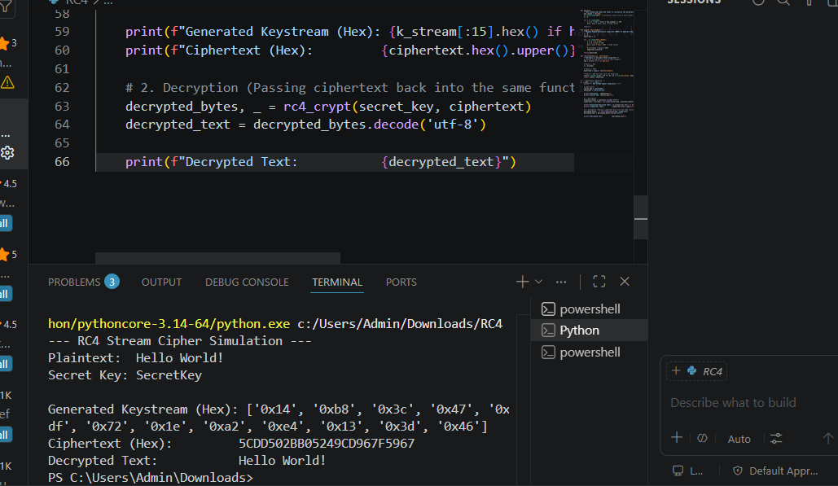

Encryption performance
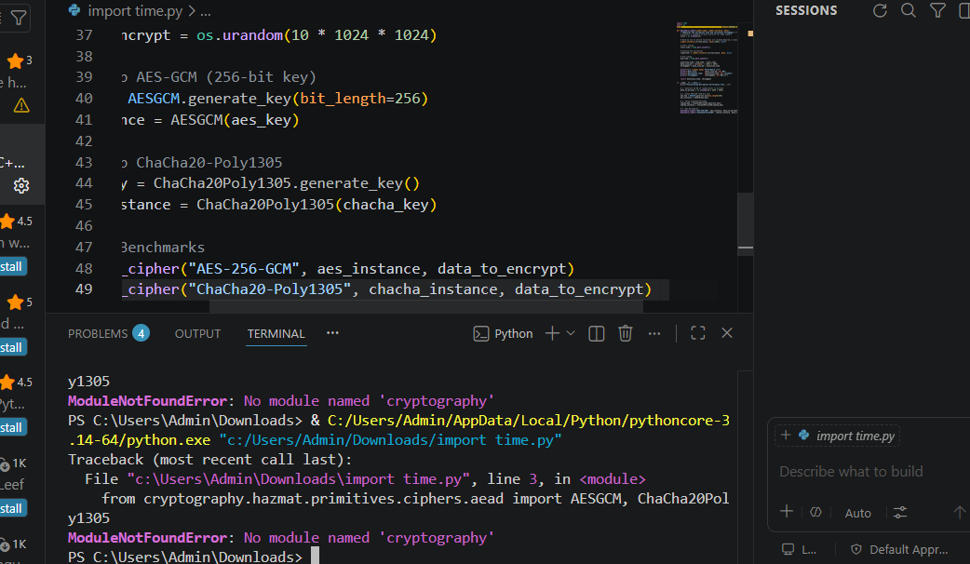
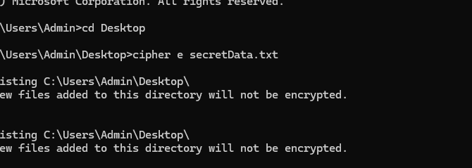

Student reflection
Python’s built-in time or timeit libraries allow you to measure execution time down to the microsecond, while the standard cryptography library provides production-grade implementations of algorithms like AES and ChaCha20 to test against. o simulate the RC4 stream cipher in VS Code, the most straightforward approach is to write a script in a language like Python or JavaScript (Node.js). Since Python is highly readable and perfect for cryptographic simulations.

Week 4

Aes encryption script

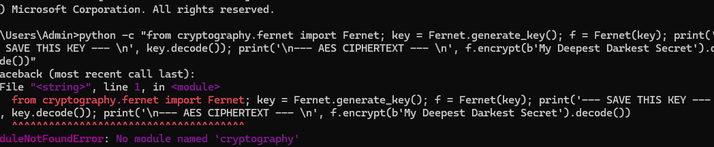

Key generation

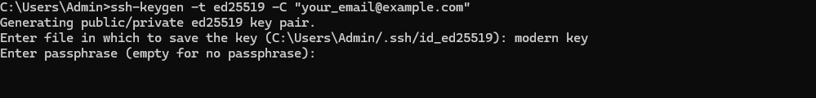
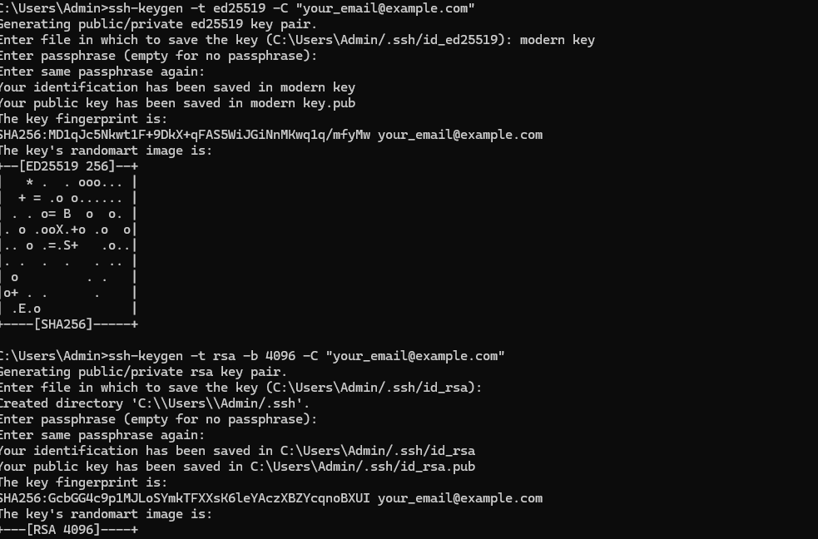

Decryption results



Student reflection
When you decrypt data, your script needs to intake the Ciphertext, the Secret Key, and the Nonce/IV, process them through the cipher, and output the result. To view the results clearly in VS Code, you can print the output both as raw bytes (hexadecimal) and as a decoded, human-readable string.

WEEK 5

RSA KEY PAIR



Public key encryption

Private key decryptionc

